Ocean Acidification FCC

By: Lexi VanBlunk

Since the industrial revolution, carbon dioxide in the air has been increasing due to a greater amount of fossil fuel use for energy. Increase uses of heating or cooling often lead to increases in CO2 use, if that energy comes from burning fossil fuels. The oceans have absorbed about 30% of this excess carbon dioxide. Ocean acidification is occurring because our ocean is absorbing so much of the carbon dioxide from the atmosphere, leading to lower pH and greater acidity. Here is the chemical equation that explains how CO2 is taken up by the ocean:

$${CO}_{2}+ H_{2}O+ {CO}_{3}^{2-}→2 HCO_{3}^{-}$$

Hydrogen in its water form is not contributing to H+ levels because it does not dissociate from the oxygen. H in bicarbonate is able to dissociate, causing the H+ concentration to increase. pH is the $-log\left[H^{+}\right]$, so an increase in hydrogen ions leads to a lower acidity.

https://www.noaa.gov/education/resource-collections/ocean-coasts-education-resources/ocean-acidification

In order to measure CO2 values in the ocean, NOAA started an ocean acidification program and has deployed buoys in all the oceans that track air and water CO2 values. Other countries have done this a well. I have picked a few different buoys to evaluate. Each buoy location can be seen in the cartopy map that I generated.

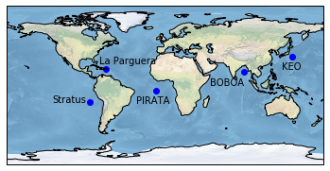

**BOBOA**

This is one of the most recent buoys, deployed in the Indian Ocean. The data available has a year range of 2013-2017. The first and last buoys have the lease data, but years Based on the graphs of each year, there seems to be a general trend of April, May, and June having increased CO2 levels in the water. The hot and dry season in the West Bengal region of India, which is that region closest to the buoy, is from March to June. An increase in the use of air conditioning and cooling technologies would require more energy, which in India, comes from burning fossil fuels, especially coal. The graph below shows how important India’s energy sector in relation to emitting carbon dioxide. Additionally, Chittagong, Bangladesh’s pre-monsoon (hot/dry) season is April-May. This explains why we see a trend of increasing CO2 in the ocean for April, May, and June.

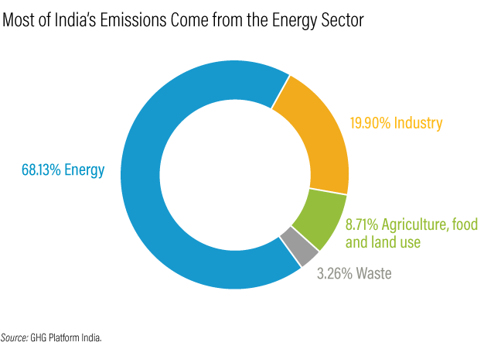

https://weather-and-climate.com/average-monthly-Rainfall-Temperature-Sunshine-region-west-bengal-in,India

https://weather-and-climate.com/average-monthly-Rainfall-Temperature-Sunshine,Chittagong,Bangladesh

Additionally, looking at all the data combined, there appears to be no upward trend of increased CO2 levels. However, there was a spike in 2015. Fossil fuel burning levels from 2013-2017 do not show much of an increase, which is most likely why there was no trend of increasing CO2 levels.

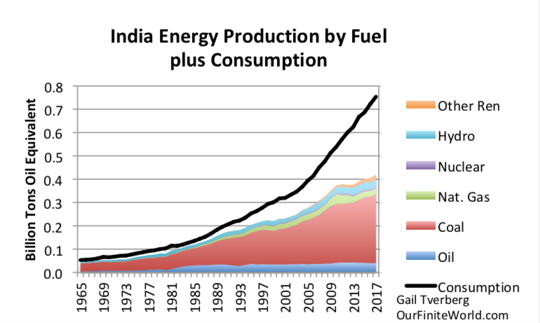

https://gailtheactuary.files.wordpress.com/2018/06/india-energy-consumption-by-fuel-plus-consumption-to-2017.png

There is also a clear spike in 2015, which can be attributed to a massive heat wave. https://en.wikipedia.org/wiki/2015_Indian_heat_wave

**PIRATA**

This buoy is located between South America and Africa, in the southern Atlantic Ocean. The data spans from 2006 to 2013. Africa is not industrialized, so it has very low contributions of CO2 into the atmosphere. Here, this data shows upward trends in CO2 from July to December and a decrease in CO2 from Feb or Mar to June or July. At this equatorial position, there are not very distinguished seasons. The trends in increased CO2 could be from CO2 traveling from other areas. There is a common trend of CO2 values increasing in later years, specifically not that they are higher than in 2006, but that they never get as low as before.

**La Parguera**

Located in the North Atlantic by Cuba and Haiti and the Dominican Republic. Time period is from 2009 to 2017. This data mostly shows trends of CO2 in the ocean increasing during the year and being lower in December or January. This pattern is very clear in the combined data figure. The weather here is very consistent, with January and December having slightly colder averages.

https://www.holiday-weather.com/varadero/averages/

Additionally, their fossil fuel production has really not changed significantly, only dropping about 2% which is why there is no overall change in CO2 emissions.

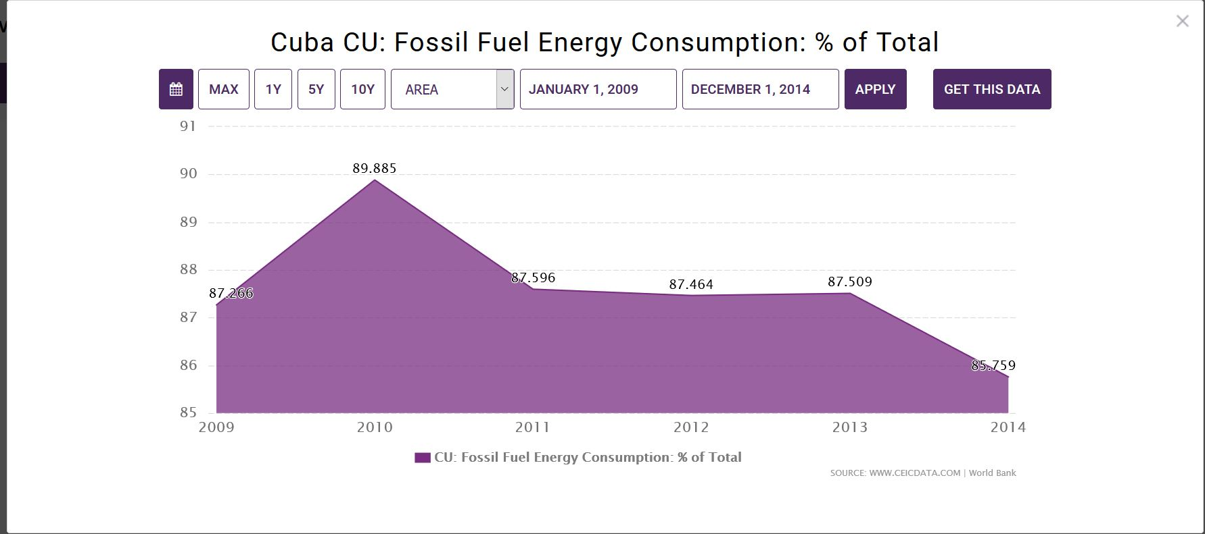

**KEO**

KEO is located very close to Japan in the Kuroshio Current. The data ranges from 2007 to 2015 and shows very clear seasonal spikes. June to October see the most CO2 absorbed by the ocean. Japan has the same seasonal cycle as the U.S., with the middle months being the hottest and requiring air conditioning, but the winters and cold months are much milder there.

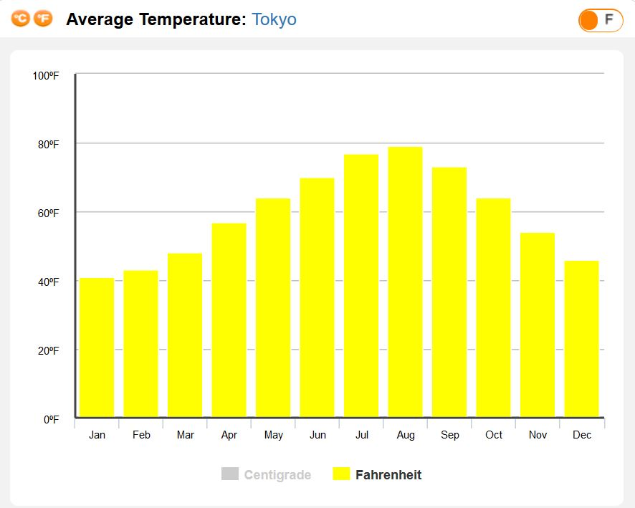

https://www.holiday-weather.com/tokyo/averages/

**Stratus**

This buoy is located in the Southern Hemisphere, in the southern Pacific Ocean, latitudinally close to where Peru and Chile meet. The data occurs from 2006-2015 and shows trends of more CO2 in December or January to March of April. The warmest weather occurs opposite to that in the US, with highs in December to March, and lows in the middle of the year. Also, the graph shows that CO2 levels do not get as low as they once did.

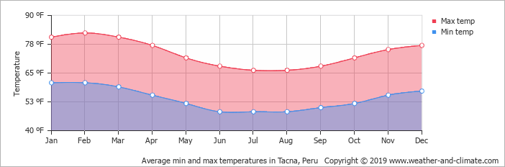

Overall, the data shows that during warmer times, more CO2 can be found in the ocean. Most of the graphs do not show an overall trend of greater CO2 emissions, due to the fact that fossil fuel consumption has not necessarily changed in the ranges of dates measured by the buoys. Therefore, the data does not confirm that the ocean is acidifying, but that there is a correlation between fossil fuel use and CO2 in the oceans.